X-ray Spectroscopy: Characterization of X-ray Emission of Different Metals

Related Topics: X-ray notation, Siegbahn notation, bremsstrahlung radiation, characteristic X-ray spectrum, X-ray edge energies, K-edge absorption, Bragg law, Bragg spectrometer, lattice planes, Miller indices, Geiger-Muller counting tube, X-ray tube, monocrystal.
Before reading the experiment guide, look up the definitions of all the related topics and make sure you understand their meaning.

Purpose
In this experiment, you will measure the characteristic X-ray lines emitted from different metals. The energies of these lines are unique for each metal and a careful analysis of the lines can reveal the inner constellation of the metal's atomic orbitals.
In order to construct an energy levels diagram for a specific metal, one has to solve two different problems. The first is a practical one – how can you measure high energy radiation that has a wavelength of a few angstroms? What method is best used for such purpose?
The second problem is how to decipher the data you measured – what energy level transitions caused each line? Can there be more than one transition? What is the selection rule that can be applied for this atomic system?
By solving these two problems, you can construct a model of the atomic levels for the element you are researching. This experiment demonstrates only one of the many spectroscopy methods that can be applied for modeling atomic orbitals and its results can be compared to those that are found in different articles and databases.

Theory

X-ray Tube Emission:
When high energy electrons interact with an atom, a few phenomena can occur. The Electric field of the atom's nucleus can decelerate the electron and cause the emission of a continuous spectrum called bremsstrahlung radiation ("braking radiation" in German). This type of radiation is emitted from every X-ray tube, regardless of the tube's type and operation conditions.
If the incident electron has sufficient energy, it can also ionize the atom, freeing an electron from the K-shell of the atom. Another electron from a higher energy level in the atom will then make the transition to occupy the vacant quantum state of the freed electron, causing the emission of a photon of a specific energy correlating to the energy gap between the energy levels:
$$hν_{photon}=E_{initial}-E_{final}$$ | (1)
where $h$ is Plank's constant, $ν_{photon}$ is the photon's frequency and $E_{initial}, E_{final}$ are the initial and final energies of the electron.
Since the energies of the photons emitted through this process are dependent only on the type of the atom and its inner atomic structure, this radiation is called the characteristic x-ray spectrum. It can be used to identify the content of alloys and other materials. Note that the characteristic X-ray spectrum is quantized (X-ray "lines"), as opposed to the continuous bremsstrahlung radiation. If an x-ray tube is operated with a voltage that is high enough to cause ionization, its emission spectrum will be the sum of those two radiations and will have a continuous part overlapping a quantized one.
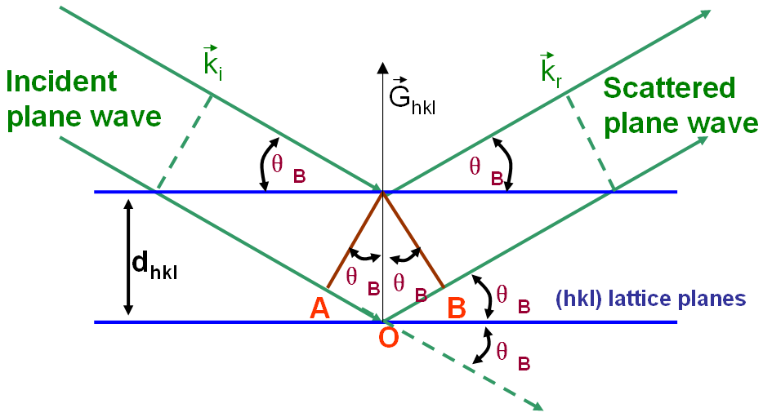
Fig. 1: Definition of Bragg angle $θ_{B}$ [1].

Bragg Spectrometer:
To measure the energy of the emitted photons, we use a Bragg spectrometer containing a known crystal as a diffracting element (see measurement chamber setup). This crystal is also called "Analyzer" since it analyses the spectrum. The X-ray radiation is reflected off the crystal planes and a constructive interference occurs in such angles that satisfy Bragg's condition:
$$2d_{hkl}sin\left(θ_{B}\right)=nλ$$ | (2)
Where $d_{hkl}$ is the crystal's interplanar spacing, $θ_{B}$ is the Bragg angle (see Fig. 1), $n$ is the diffraction order and $λ$ is the photon's wavelength.
By measuring the intensity of the radiation at different Bragg angles we can construct the radiation's spectrum, using
$$E=\frac{hc}{λ}$$ | (3)
to write
$$E=\frac{hc}{2d_{hkl}}⋅\frac{n}{\sin\left(θ_{B}\right)}$$ | (4)
Note that this equation translates Bragg angles into energies using the known value of $d_{hkl}$ and is dependent on the diffraction order $n$. Thus, to use this equation one must first identify the regions of each diffraction order in the spectrum and then use the correct $n$ in the equation.

The System and Equipment
Fig. 2: Experiment System – An X-ray Unit.
This experiment is performed using an X-ray unit (see Fig. 2) which includes an X-ray tube on the left side and a measurement chamber on the right.
In the X-ray tube, a beam of accelerated electrons is incident on the tube's anode, causing the emission of bremsstrahlung radiation and the characteristic X-ray lines of the anode's metal. The X-ray radiation then passes through a small hole into the measurement chamber. The size of the hole can be adjusted by inserting a diaphragm into it. This controls the focus of the X-ray beam and its intensity.
After passing through the diaphragm, the X-ray beam is incident on a crystal and scattered. The scattered beam is detected using a Geiger-Muller Counter tube (GM counter, see relevant description document at course site) that counts the photons at each Bragg angle. Both the GM Counter and the crystal are set on a goniometer, which enables precise control of the crystal angle and measures the angle of the scattered beam (Fig. 3).
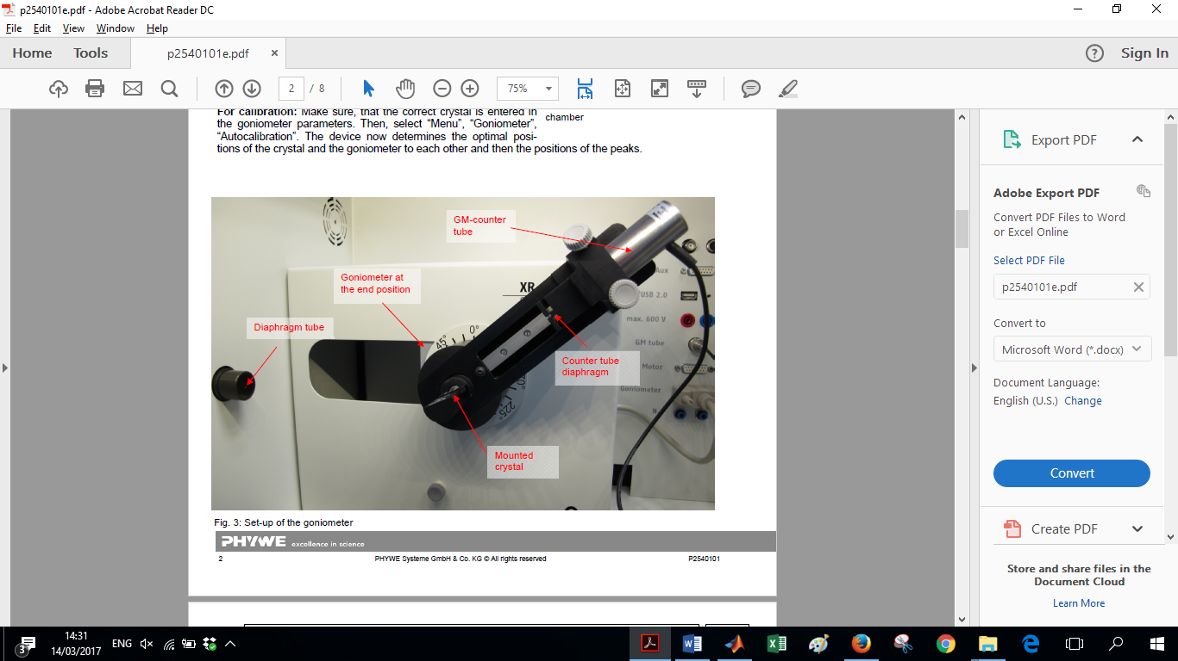
Fig. 3: Measurement Chamber Setup.
There are four different X-ray tubes: Cu, Fe, Mo and W. In each tube a beam of electrons is accelerated using a high voltage (ranging from 10keV to 35keV). The voltage of the tube determines the energy of the radiation than can be emitted and the tube's current controls the intensity of the radiation.
Fig. 4: Control Panel on the X-ray Unit.
The experiment system includes two monocrystals as analyzers: LiF and KBr. Those crystals differ in their interplanar spacing but have the same crystal structure.
The whole X-ray unit is controlled through both a control panel (Fig. 4) on the front lower part of the unit and a computer program (the Icon "measure" on the Desktop).

Preparation Questions
- Read "Nomenclature system for X-ray spectroscopy" and explain the terms: "normal X-ray lines", "Diagram levels", "orbital notation".
- What is the crystal structure and interplanar spacing ($d_{hkl}$) of the LiF(200) and KBr(200) crystals? (you can use [3]).
- If we could cleave the LiF crystal to create LiF(220), what would be it's interplanar spacing $d_{220}$? Use
$$d=\frac{a}{\sqrt{h^{2}+k^{2}+l^{2}}}$$
Where $a$ is the crystal's lattice constant.
- Why is it important in a Bragg spectrometer that the crystal will be a monocrystal?
- Find the atomic X-ray levels (electron binding energies) of Fe, Cu, Mo, W. For each metal, between which levels the transitions have an energy of $5-30keV$? What are their notations in Siegbahn notation?
- How many diffraction orders ($n$) can be detected using a KBr crystal if $E_{photon}=8keV$?
- Which of the atoms in the crystals LiF, KBr has an edge energy in the range $5-35keV$?
- What are the criterions for choosing a crystal to analyze an X-ray spectrum (versus other ranges of spectrum)?
- At what angle will an energy of $10keV$be measured in a Bragg spectrometer with a LiF(200) crystal assuming $n=1$?
- Given that the energy of $K_{α_{1,2}}$ is less than $K_{β},$ plot the intensity as a function of Bragg angle for these two diagram lines (as delta functions).

Part 1 (First Lab Meeting)
Do not perform experiment without receiving safety and operational instructions beforehand!
In the first lab meeting you will measure the spectrum emitted from the X-ray tube and analyze its components. Also, you will determine what parameters in the Bragg spectrometer (crystal type, diaphragm size, scan angles) give the best energy resolution.

Experiment Setup
- Write down which X-ray tube is in the X-ray unit (written on the side of the tube). What metal is the anode made from? What is its atomic number?
- Insert a diaphragm tube of 2mm in the hole of the X-ray beam.
- Insert a crystal to the goniometer, either LiF or KBr. Handle the crystal delicately and don't touch its surface. Write down which crystal you use. What is its interplanar spacing?
- Close and lock the measurement chamber's door by pressing the lock button:
- In the X-ray tube menu (if you use the program, click on the tube image) set the anode voltage to 35keV and the current to 1mA.
- In the goniometer menu (if you use the program, click on the measurement chamber image) choose the parameters: 1:2 coupling mode, angle range $3°-75°$, increment of $0.1°$ and integration time ("Gate time") of 2sec. In this coupling mode, the goniometer makes sure the crystal and the GM counter are moved symmetrically to enable measuring Bragg angles. Why do we not start the scan from the angle $0°$? How will increasing the integration time change the measurement?
- Calibrate the goniometer using the control panel on the X-ray unit (see Fig. 3): Select "Menu", "Goniometer", "Autocalibration" and press start. This process determines the optimal relative position of the crystal and the GM counter and their position relative to the X-ray beam. Make sure that by the end of the calibration the graph of the intensity vs the angle (shown on the panel) displays well defined peaks. If not, call the instructor.

Experiment procedure
- After finishing the setup, start the first measurement by clicking the red circle on the top left of the program interface. The measurement data should be displayed on a graph in the program as it is acquired. When the measurement is finished, select "send all data to measure" and press "OK".
- To save the measurement, export the data to a txt file by clicking "Measurement", "Export Data", "save to file" (“as numbers”).
- Load the measurement data into MATLAB and plot the radiation intensity versus Bragg angle. Identify the regions of each diffraction order and cut out the region of $n=0$ since it contains no spectral information. Try displaying the intensity in log-scale (use the function semiology()). Does it make the lines clearer? Can you identify the bremsstrahlung radiation?
- Translate the Bragg angles into energies and plot the spectra from the different orders on the same graph. Do they match? Do the characteristic X-ray lines appear at the energies you found in preparation question No. 5?

Comparing the Crystals
- Switch the crystal in the Bragg spectrometer and perform an autocalibration.
- Repeat the measurement of the spectrum using this analyzer. What is different from the first scan and how can you explain it? Adjust the scan angles if needed.
- Repeat the process of transforming Bragg angles into energies and plot the spectra measured with the two different crystals on the same graph. How do they differ? What is the effect of using a different crystal as analyzer?
- When using a KBr crystal, a "step" in the GM counter reading is noticeable at a specific angle. The step's energy corresponds with the k-edge absorption of Br. Calculate this energy and compare it to known value.

Comparing Diaphragm Sizes
- Choose the crystal that gave better results and put it in the Bragg spectrometer.
- Switch the diaphragm with one that has a different size.
- Perform an autocalibration and a scan. Is the change of diaphragm size noticeable? How did it affect the measured spectrum?
- Plot the spectra from the two different diaphragms (and same crystal) on the same graph. Since the diaphragm affects the intensity, first normalize the spectra (similarly to a probability function distribution). You can use the functions sum(), trapz() etc. to perform the integration. What can you conclude regarding the effect of diaphragm size on the measurement?

Advanced Analysis (complete at home, before the second lab meeting)
- Determine the energy of each X-ray line in the three measurements you took. What is the best criterion for choosing that energy? Consider maximal intensity, centroid of the distribution and Gaussian fit. Do different criterions give the same results? You can perform a fit to Gaussians using cftool in MATLAB.
- Determine the error in energy. What is more dominant? The detector sampling resolution or the width of each line? Why is there a non-zero width to each line?
- Compare the error of the different diffraction orders. How is it affected?
- Determine the noise level and calculate SNR (Signal to Noise Ratio) for each line. What parameters affect it? How does the noise affect the measurement and how can you negate its effects?
- Compare the lines you measured to those that can be found in literature and databases, and determine what transition/s caused each line. Does the measurement resolution explain why a single measured line is caused by more than one transition?
- Construct an energy level diagram based on your measurements and the known values you found. What can you conclude?
- Determine the parameters that give the best resolution in the Bragg spectrometer. Bring these specifications to the next lab meeting for the second half of the experiment.

Bibliography:
[1] Bragg angle image was taken from:
http://www.globalsino.com/EM/page3882.html
[2] The system's images were taken from:
http://repository.phywe.de/files/versuchsanleitungen/p2540101/e/p2540101e.pdf
[3] X-ray Data Booklet: http://xdb.lbl.gov/

